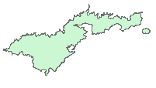

Rise
Run
Slope Angle
(Degree)
Figure 1—Percent slope = Rise ÷ Run *100.
Degree slope equals the Slope Angle. (after ESRI 2004).

Note: Remember the filename must be less than 13 characters.
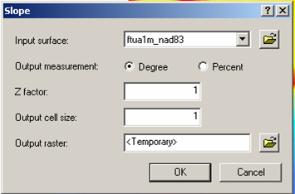
Figure 2—The slope window.
Benthic Classifications

Introduction

In this lesson, you will learn how to work with bathymetry to get a better understanding of what the ocean floor looks like. You will learn how to work with the raster calculator and how to work with ArcInfo GRID. Please keep in mind, in this lesson, typing accurately is very important.

Objectives

At the end of this lesson, you will be able to:

- Do a slope analysis.
- Use Raster Calculator to do simple analyses.
- Use Grid to process a short command sequence.
- Define: Slope, Bathymetric Position Index, benthic, standard deviation and benthic zones.

The first analysis you will do is a slope analysis for Pago Pago Harbor. Slope is a measure of the steepness of the landscape. Areas with a greater degree of slope are steeper. Slope is calculated based on elevation (on land) or depth (under water) values. Slope is calculated in one of two ways: degree of slope or percent slope (Figure 1).

1. In the Spatial Analyst toolbar choose Spatial Analyst →Surface Analysis→Slope. This will bring up the Slope dialog box (Figure 2).

a. Make sure the fagatele1m grid is showing in the Input Surface field.

b. Leave the Output Measurement as Degree.

c. Change the Output Cell Size value to 1. Click on the folder next to the Output Raster field and give a name to the file that will be created.

Azimuth is the direction from which the light is coming. North is 0° and, moving in a clockwise direction, the degrees increase. The most commonly used azimuth for mapping is 315, which would be northwest.

Altitude is the angle of the light source (sun) above the horizon. Forty-five degrees is the most commonly used altitude.

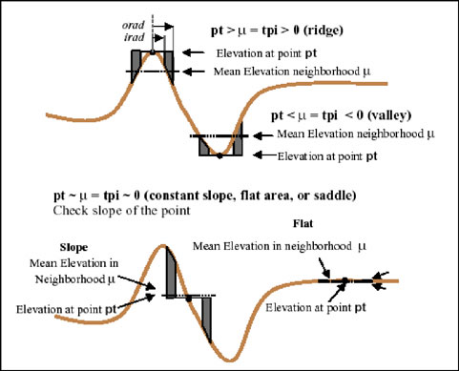
The second part of the process will be to calculate Bathymetric Position Index. BPI determines where each pixel is in relationship to the pixels around it (Figure 3). The results of the BPI will give a better picture of what type of features are on the seafloor.
Figure 3 (after Weiss 2001)

You will be working with a 5 meter grid of Pago Pago Harbor. BPI isolates features of a certain size, chosen by the user. In this case, you will look at small features and large features, so BPI will be calculated twice. Broad-scale BPI refers to large features and fine-scale BPI refers to small features.

The general form of the equation you will use is:

BPI<scalefactor> = int((bathymetry – focalmean(bathymetry, annulus, irad, orad)) + .5)

Scalefactor = is the map units of the outer radius multiplied by the resolution of the grid. In this case, if we wanted a scalefactor of 100, meaning we are interested in features around 100 meters in size, we would use an outer radius of 20 (5 m resolution * 20 = 100).

Bathymetry = this is the name of the bathymetry grid, ppg5m84_neg, in this case.

Annulus = this is the shape of the area that Spatial Analyst will use to calculate BPI. Spatial Analyst can use a number of shapes, including a circle and an annulus, which is shaped like a donut.

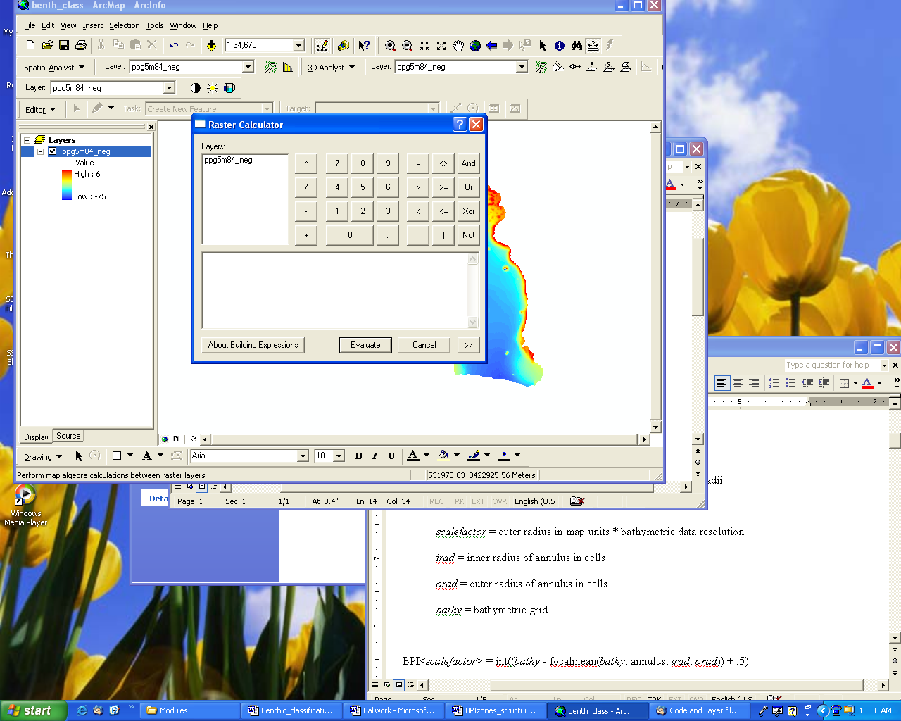
irad = this is the inner radius of the annulus.
Figure 4

orad = this is the outer radius of the annulus.

- Open ArcMap and load the ppg5m84_neg bathymetry grid.
- Make sure spatial analyst is turned on and the toolbar is visible.
- Go to Spatial Analyst → Raster Calculator.
- The name of the bathymetry grid should be listed in the upper left in the raster calculator (Figure 4)

NOTE: It is extremely important to type things into the raster calculator exactly as they are shown. Spaces matter!!!

  - Double-clicking on the name of the bathymetry grid will make it appear in the bottom box. To do anything with it, you will have to type in commands to tell spatial analyst what to do. For now, make sure the bottom box is empty.

  - First, we will calculate broad-scale BPI: Type the following commands into the bottom box of the raster calculator.

int(([ppg5m84_neg] – focalmean ([ppg5m84_neg], annulus, 5, 40)) + .5)

    - Be patient! This may take a few minutes.
    - When it is finished, right click on the new layer and choose Make Permanent. Important: Save your grid in the same folder that contains the bathymetry and slope grids.
    - Rename the title of the layer by right-clicking on the name of the layer and choosing Properties. Click on the General tab and rename the layer ppg_200.
    - Create a layout showing broad-scale BPI. Be sure to include an inset map, title, name, date, north arrow, and scale bar.

  - Now, calculate fine-scale BPI. A slightly different equation is used for this because you will use a circle instead of an annulus to calculate BPI. When using a circle, spatial analyst automatically assumes and inner radius of 1, so you do not have to define the inner radius. Open the Raster Calculator again. Type the following equation into the raster calculator as you did before:

int(([ppg5m84_neg] – focalmean ([ppg5m84_neg], circle, 2)) + .5)

    - Make the new grid permanent and rename it ppg_10. Important: Save your grid in the same folder that contains the bathymetry and slope grids.
    - Create a layout showing fine-scale BPI.
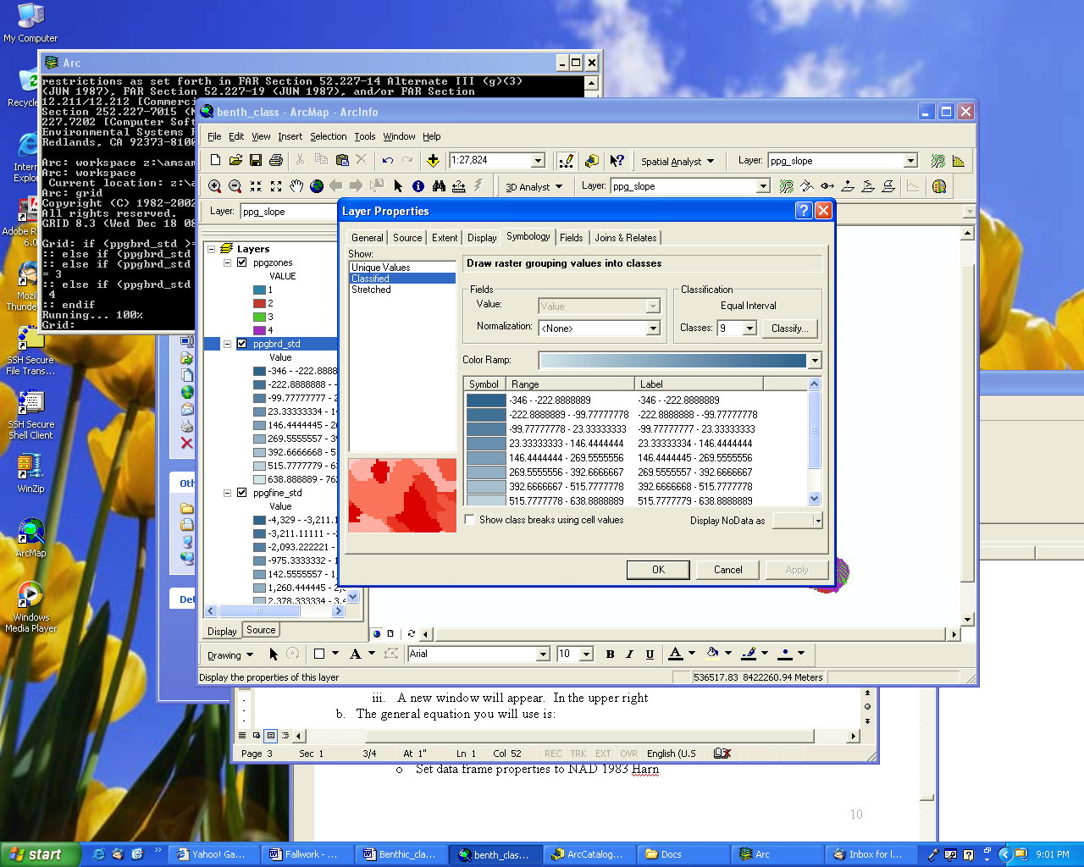
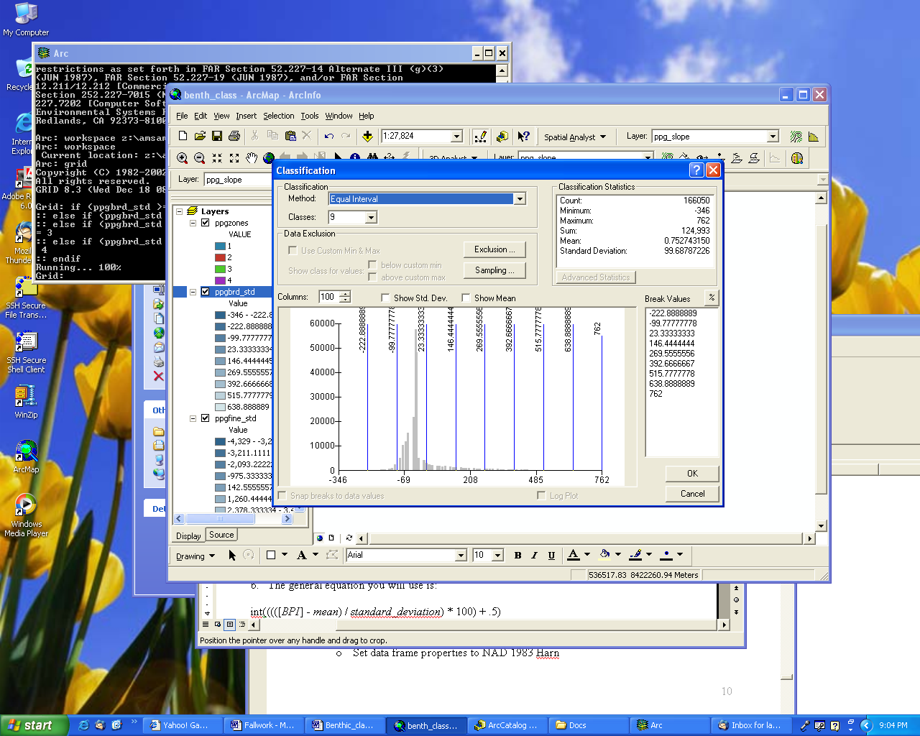
Figure 3
Figure 4
- Now the BPI grids must be standardized to the same scale.

  - The first thing you will need to do is find out the mean and standard deviation for each of the BPI grids.

    - Right click on the fine-scale BPI grid and choose Properties
    - In the Symbology tab, click of the Classify button (Figure 3).
    - A new window will appear. In the upper right corner, you will find the mean and standard deviation values. Write these down, all of the digits, for use a little later (Figure 4).
    - Close the Classification Window and the Properties window.
    - Do the same for the broad-scale BPI.

  - The general equation you will use to standardize the BPI grids is:

int(((([BPI] - mean) / standard_deviation) * 100) + .5)

So, if an example grid, named bpi_test, has a mean of 3.25 and a standard deviation of 2.25, the equation would look like:

    - int(((([bpi_test] – 3.25) / 2.25) * 100) + .5)

    - In Raster Calculator, type the above equation.

    - Replace [BPI] with the name of your fine-scale BPI grid.

    - Replace mean and standard_deviation with the values you wrote down for your fine-scale BPI.

    - Click the calculate button.

    - When ArcMap is finished making the new grid, make it permanent and name it ppgfine_std. Important: Save your grid in the same folder that contains the bathymetry and slope grids.
    - Repeat these steps for the broad-scale BPI.

  - Save your project and exit ArcMap.

Benthic Zones

Now you will actually calculate benthic zones. Benthic zones are broad classifications of the landforms on the ocean floor. Benthic zones are calculated using broad-scale BPI

- Go to Start → Programs → ArcGIS → ArcInfo Workstation → Arc

- First, set your workspace. Setting the workspace tells Arc where to look for files and where to save files. Set your workspace by typing:

  - workspace <location of your BPI and bathymetry files>
  - For example, if your files are saved on the d: drive in a folder named grids, you would type: workspace d:/grids
  - You can check to see if you did it correctly by typing workspace again. It will tell you where it is saving and looking for files.

- Type grid.

- Here are the variables for making benthic zone classifications:

B-BPI = the filename of broad scale BPI grid
out_zones = name of the output grid
slope = the slope grid derived from bathymetry
gentle = the user defined slope value indicating a gentle slope
- Type the following commands into grid. The value 100 is what Arc uses to mean 1 standard deviation. It is extremely important to type it accurately and make sure all of the signs are facing the right
- direction or the resulting grid will not come out correctly. Replace B-BPI with the name of your standardized broad-scale BPI grid. Replace out_zones with a name of your choice for the file. Replace slope with the name of the slope grid. Use 5 for the slope value (in degrees). Hit enter at the end of each line. If you make a mistake, you will have to start over. Spaces matter.

if (B-BPI >= 100) out_zones = 1
else if (B-BPI <= -100) out_zones = 2
else if (B-BPI > -100 and B-BPI < 100 and slope <= slopevalue) out_zones = 3
else if (B-BPI > -100 and B-BPI < 100 and slope > slopevalue) out_zones = 4
endif
- Open ArcMap and open the project you were working with before.

- Add the grid you just created. If any zones are missing (indicated by a missing number between 1 and 4), you will need to redo the zone calculation.

  - Rename the zones by going to the properties for your zone grid. In the middle box under the symbology tab, there is a column named Values. Click on each one and type in the names below:
    - 1 = Crests
    - 2 = Depressions
    - 3 = Flats
    - 4 = Slopes

  - Click Ok.

- Create a layout showing the zones for Pago Pago Harbor. Be sure to include a smaller location map with Tutuila for reference.

Questions:

- What is the scalefactor of the broad-scale BPI you calculated (refer to page 1 for how to calculate scalefactor)? Show your work.

- Caculate the following for BPI. Show your work:
  - If you want a scalefactor of 400 and your grid resolution is 10 m, what outer radius should you use?
  - If you are using an outer radius of 16 and the grid resolution is 5 m, what is the scalefactor of the BPI?

- What is the definition of standard deviation (look this up in a dictionary or on the internet)? What percentage of values lies within one standard deviation of a mean?
- If you had the opportunity to take a submersible down in the bay, what areas would you like to see? Remember, some of the more complex areas may be areas that have more diverse fish and coral communities. Mark the areas on your benthic structures map with a pen and explain why you chose the areas you did.

What to turn in

- Answers to the questions above.

- Layouts showing fine-scale BPI, broad-scale BPI and benthic zones.

.

